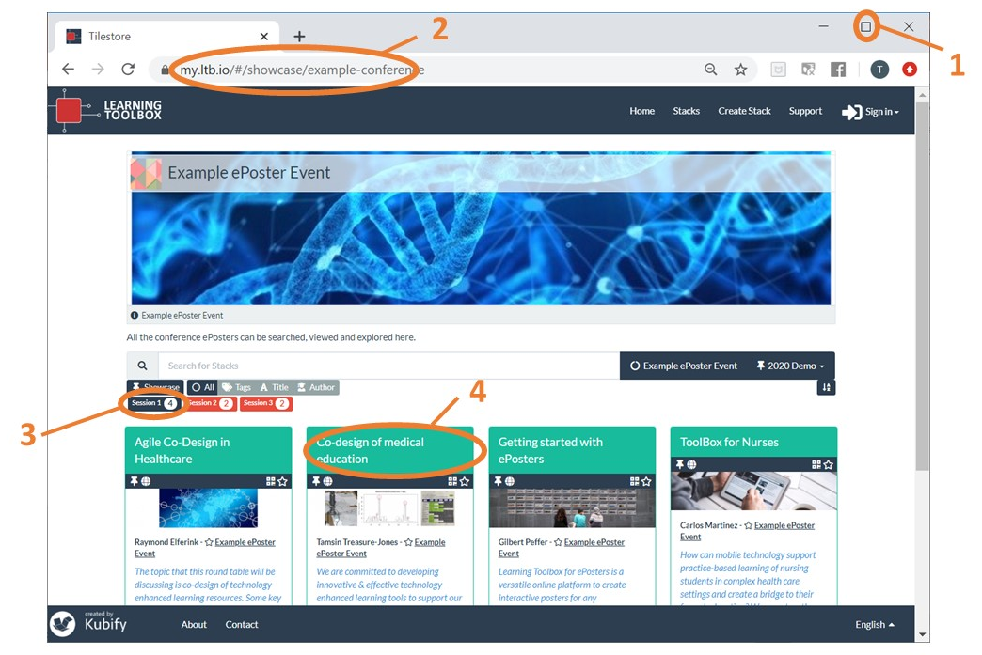
Learning Toolbox ePoster Presentation Quick Guide for Chairs_
Setting up the computer for the ePoster Presentations
- Open a web browser (Google Chrome is our recommendation) and set to full-screen (1)
- Go to the Conference ePoster Showcase website (2)
ADD LINK HERE
- Click on the session id (3) that you are chairing. Now only ePosters in this session are shown onscreen.

Opening an ePoster for the presenter
We recommend that the technical person or the Chair opens each presenter’s ePoster. This can be done as the Chair is introducing the presenter, so the ePoster is onscreen when the presenter arrives on stage.
- Scroll down the screen to find the correct ePoster. Titles may vary from original if the presenter has edited it to shorten it onscreen. In this case the presenter should be able to find their ePoster.
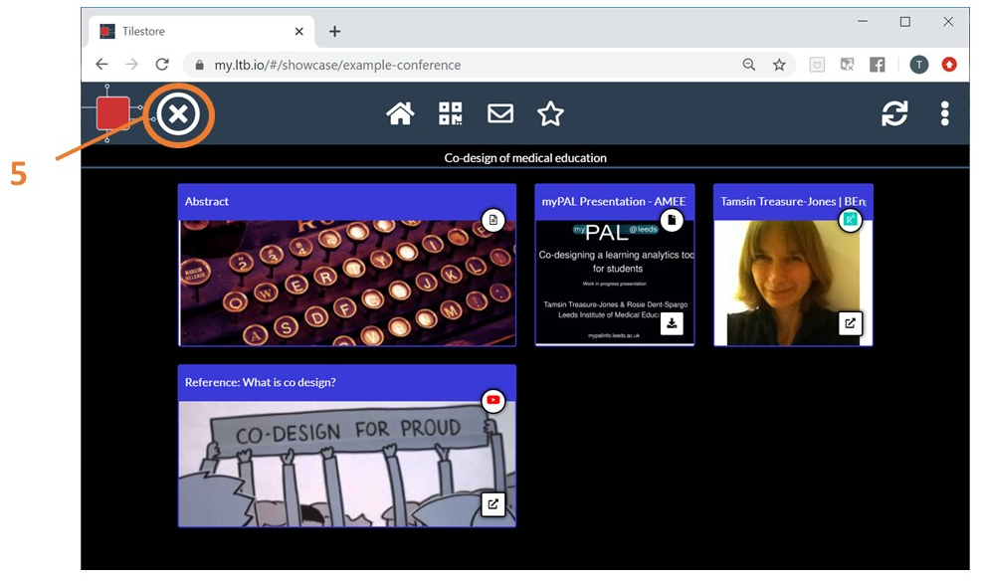
- Click on the ePoster’s title bar on that ePoster (4).This will open the ePoster and the author can now navigate it as normal and present whatever material they wish from within the ePoster.

Moving to the next ePoster
- Click on the X to close this ePoster (5)
- You are now returned to the ePoster showcase. You can now find and open the next ePoster.

