Learning Toolbox ePoster Presentations – Advice for presenters
Version 2.0
Tips on presenting your ePoster
- Just give the highlights. You only have a short time, so do not try to tell everything about your work. Just tell people the most interesting highlights/results - the story of your work.
- Tell people what else they can find inside your ePoster but do not show them all of this, you will not have time. This could involve opening up a few specific tiles to show media in there (images, videos, powerpoint) or just giving a 3 minute pitch/summary of your work and simply telling people where they can find more in the ePoster.
- Make sure that everything you need is inside your ePoster. You will only have access to your ePoster during the presentation, so make sure that anything you want to show is in your ePoster.

Practising your presentation
Presenting with ePosters is new, so we recommend you practise. You will present from a computer and when you get to the stage your ePoster will already be open and showing in preview mode in the web browser. This view will be projected for the audience to see. You can then move around your ePoster as normal.

You can practise this on your own computer from Learning Toolbox, by clicking on preview (1) to see your ePoster in preview mode (2).

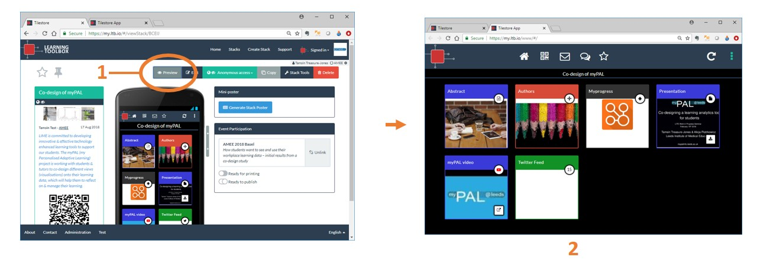

In this preview mode you can click on tiles to open them and view the material as normal. So you can practise moving around your ePoster as you want to do during your presentation.

In this preview mode you can also change the ePoster appears on screen by clicking on the 3 dots menu (3). The ePoster is shown by default in a 4 tiles wide view, but you can choose to show it in other formats (4). You can also choose to make it full-screen (5). To come back from full-screen at any time just press the Esc key on your computer keyboard.
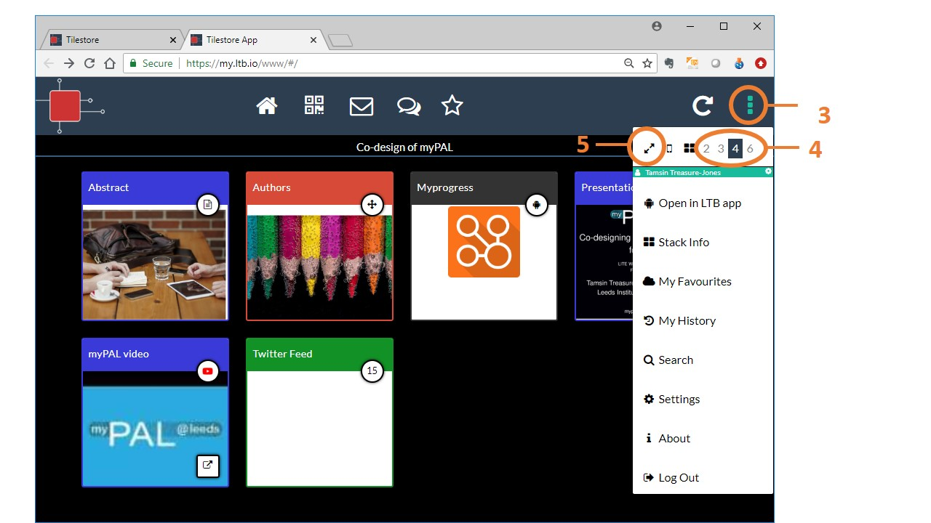

If you are using a presentation then you can simply click on it to open it in PDF format (6). You can then click on the expand button (7) to make it show in a full-screen view and click through it as normal. To come back from the full-screen view again just click on your keyboard’s Esc key. If your presentation was originally a powerpoint presentation in which animations or embedded videos are used and you need to use them in the presentation then you should instead click on the download button (8) to download the original file. Please note the time it takes to download will depend on the size of your original file and the speed of the network. Once downloaded you can open and present from it as normal.
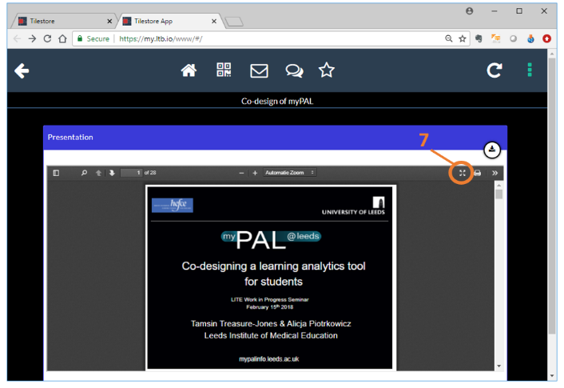
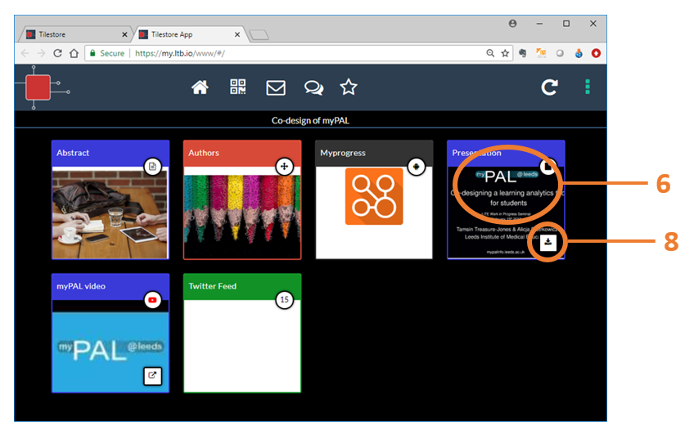

However, again we would emphasise that what is important in such a short presentation is to get your main story/message across to the audience, so that they then want to explore your ePoster themselves afterwards. So keep it simple and clear. You and your story are more important than the technology here!

